The CAFTCAD Awards,
The First Ever Canada-Wide Costume Arts and Design Awards,
to be held on
Sunday, February 10, 2019 at the
Aga Khan Museum
In Toronto

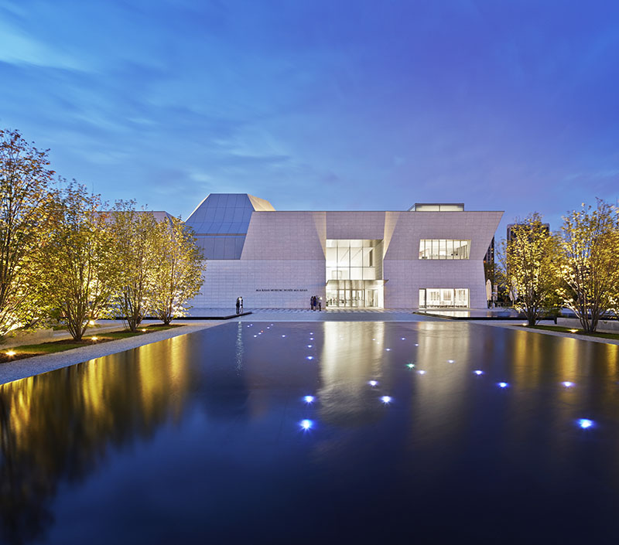

Follow us on:
Web: www.caftcad.com
Facebook: @caftcad
Instagram: @caftcad
Twitter: @caftcad

Toronto. May 17, 2018. Alex Kavanagh, President of The Canadian Alliance of Film & Television Costume Arts & Design (CAFTCAD) and Joanna Syrokomla, Chairman of the event are delighted to announce that the CAFTCAD Awards will take place on Sunday, February 10, 2019. The venue for the awards will be the Aga Khan Museum in Toronto.

“The Aga Khan Museum houses rare masterpieces of textile, colour and art, and its vast collection mirrors the quality of artistic design we will be celebrating at the CAFTCAD Awards. The glass jewel box of the atrium with its dramatic night time lighting will be a perfect showcase for the nominated costumes on display for our guests, while the intimate auditorium brings a warmth to the evening’s award show,” said Syrokomla. “Choosing early February for the first annual CAFTCAD Awards places it at the forefront of the awards season and rides the crest of excitement generated by those events, perhaps even inciting a swath of glamorous red gowns for the red carpet so close to Valentine’s Day.”

The Aga Khan Museum (https://www.agakhanmuseum.org ) is located at 77 Wynford Drive in Toronto.

Costume designers and artisans who are either Canadian citizens or permanent residents of Canada and have worked on projects (feature film, short film, television, music videos, web series, commercials) which have been produced within Canada (costumes must have been primarily built/created in Canada) will be eligible. The eligibility period for the 2019 CAFTCAD Awards is December 1, 2017 to December 1, 2018 for projects that have been released theatrically, online, on streaming services, on television/cable, or participated in accredited film festivals.

The final list of prize categories is still in development, but will include: Film: Contemporary, Film: Period, Film: Sci-Fi/Fantasy, TV: Contemporary, TV: Period, TV: Sci-Fi/Fantasy, Original Web Series, Commercials, Music Videos and Short Films.

ABOUT CAFTCAD
Formed in 2008, CAFTCAD is an association of individuals interested in promoting costume design for film, television and media from both an artistic and technical perspective. Our goal is to enrich our community with a national organization that is inclusive of experience and talent.
The Alliance provides an open forum for discussion, networking and knowledge sharing for our members through periodic seminars, workshops, exhibits and an online forum. We explore the areas of individual design approach, illustration, and advancements in film technologies. We celebrate the richness of historic and contemporary fashion and its relationship to our craft.
Our vision is to increase awareness and the value of costume arts and design as a powerful element in the collaborative process of filmmaking; furthering international recognition of the creative talent we have in Canada.

ABOUT THE AGA KHAN MUSEUM

The Aga Khan Museum in Toronto, Canada, has been established and developed by the Aga Khan Trust for Culutre (AKTC), which is an agency of the Aga Khan Development Network (AKDN). The Museum’s mission is to foster a greater understanding and appreciation of the contributions that Muslim civilizations have made to world heritage while often reflecting, through both its permanent and temporary exhibitions, how cultures connect with one another. Designed by architect Fumihiko Maki, the Museum shares a 6.8-hectare site with the Ismaili Centre, Toronto, which was designed by architect Charles Correa. The surrounding landscaped park was designed by architect Vladimir Djurovic.

Media contact: Cynthia Amsden Roundstone Communications, Cynthia@roundstonepr.com, 416.910.7740

